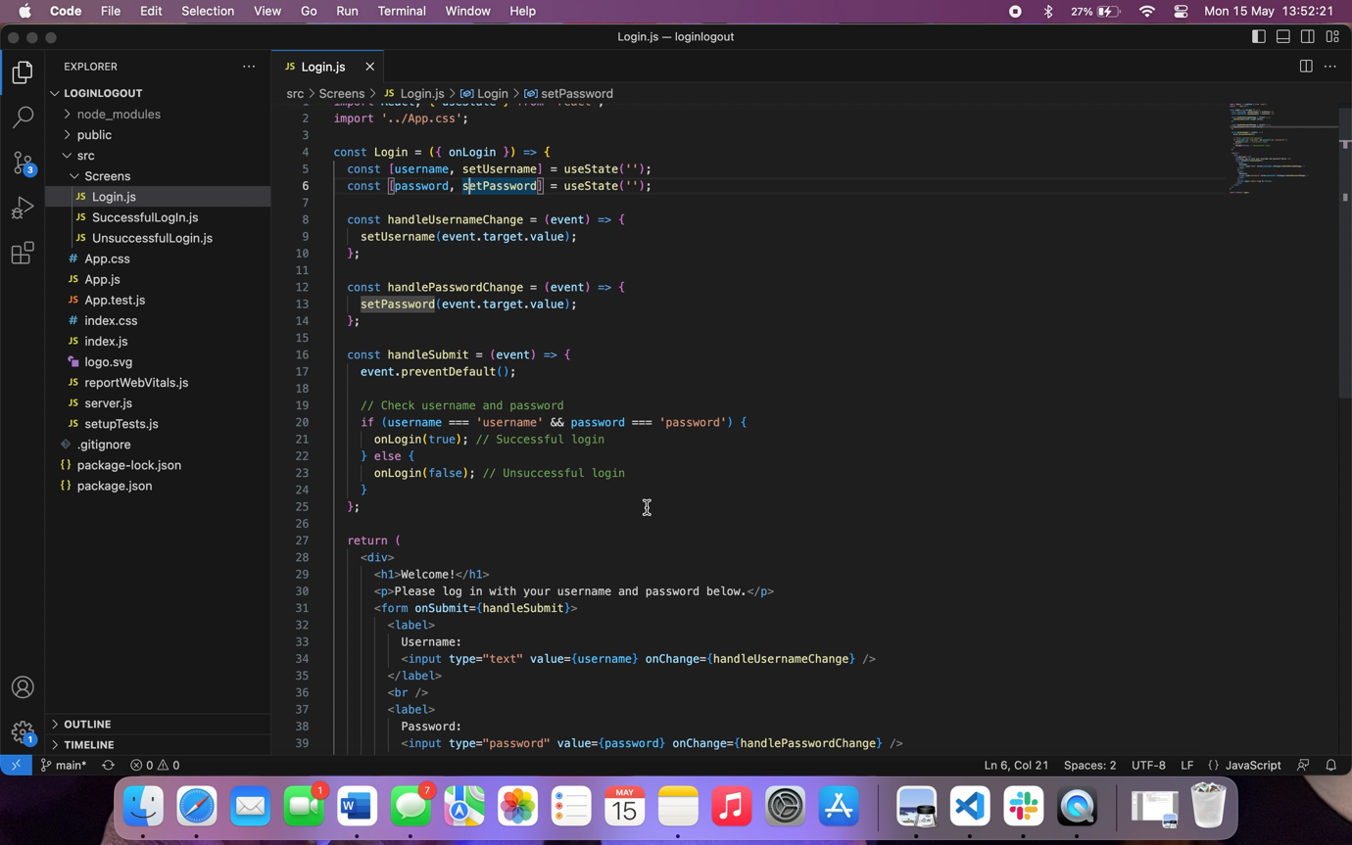***Screen recorded demo version of webpage working.***

Username must be ‘username’ and password must be ‘password’ to log in successfully.